

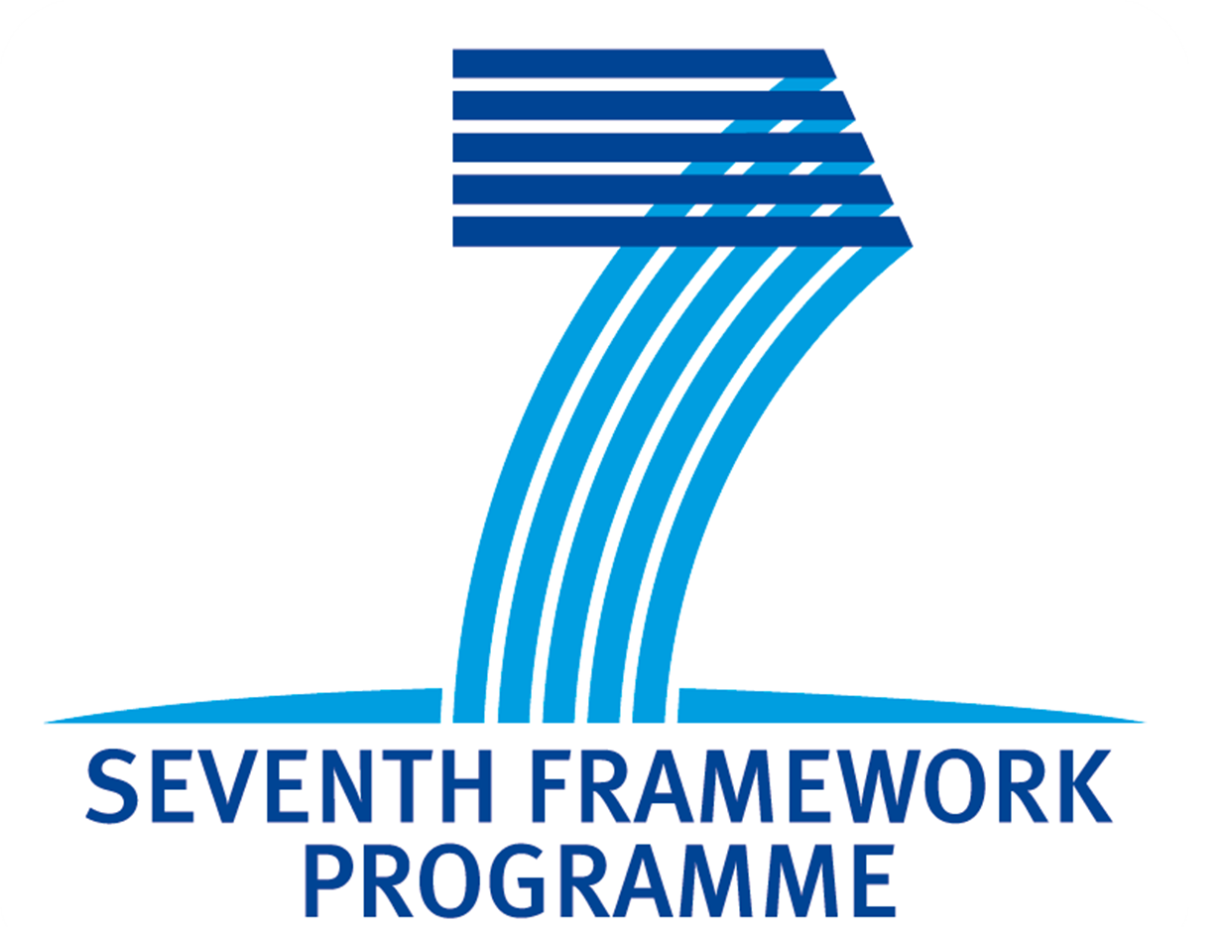
FP7-REGPOT-2009-1

Faculty of Technology and Metallurgy University of Belgrade -
Nanotechnology and Functional Materials Centre
Serbia

is organizing

Second International Workshop
on

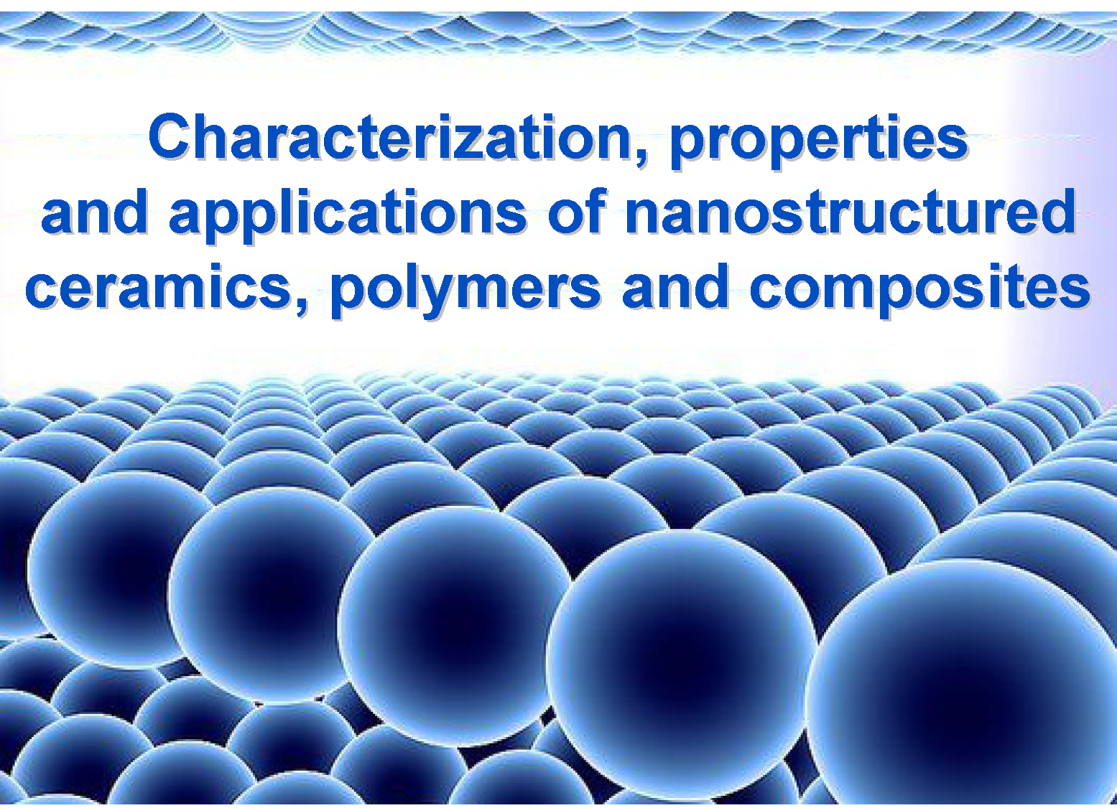

Belgrade, Serbia, October 24 - 25, 2011

The Second International Workshop aims to present current advances in characterization, properties and applications of nanostructured ceramics, polymers and composites. It will be organized as oral sessions with invited speakers from the international as well as local academic, scientific, and industrial communities, a poster session in which young researchers will have the opportunity to present their research, and a round table that will initiate discussions on fundamental issues as well as on various themes about different aspects of production and application of nanomaterials.
The Workshop is organized as a part of the FP7 project Reinforcing of Nanotechnology and Functional Materials Centre (Grant agreement No: 245916) - FP7-REGPOT-2009-1.

Invited speakers:

Bianca Baroli
School of Pharmacy, University of Cagliari, Italy
Smadar Cohen
Dept. of Biotechnology Engineering, Ben-Gurion University of the Negev, Israel
Ovidiu Ersen
Institut de Physique et Chimie des Materiaux de Strasbourg, France
Branislav Jelenkovic
Institute of Physics, University of Belgrade, Serbia
Josè M. Kenny
Materials Science and Technology Laboratory, University of Perugia, Italy
Ion Mihailescu
National Institute for Laser, Plasma, and Radiation Physics, Buchurest, Romania
Eriks Palcevskis
Institute of Inorganic Chemistry, Riga Technical University, Riga, Latvia
Dominique Perreux
MaHyTec Ltd, University of Franche-Comté, Dole, France
Zoran Petrovic
Institute of Physics, University of Belgrade, Serbia
Velimir Radmilovic
Faculty of Technology and Metallurgy University of Belgrade, Belgrade, Serbia
Christian Theel
INP Greifswald e.V. - FROM THE IDEA TO THE PROTOTYPE, Germany

Program Committee:
Chair: Uskokovic Petar, University of Belgrade
Members:
Aleksic Radoslav, University of Belgrade
Ersen Ovidiu, Institut de Physique et Chimie des Materiaux de Strasbourg
Janackovic Djordje, University of Belgrade
Kenny Josè M., University of Perugia
Mihailescu Ion, National Institute for Laser, Plasma, and Radiation Physics, Buchurest
Palcevskis Eriks, Riga Technical University
Perreux Dominique, University of Franche-Comté, MaHyTec Ltd
Popovic Ivanka, University of Belgrade
Radmilovic Velimir, University of Belgrade

Organizing Committee:
Chair: Obradovic Bojana, University of Belgrade
Members:
Orlovic Aleksandar, University of Belgrade
Petrovic Rada, University of Belgrade
Radojevic Vesna, University of Belgrade
Stamenkovic Ivan, University of Belgrade

Contact person:

Prof. Bojana Obradovic (bojana@tmf.bg.ac.rs)
Chair of the Organizing Committee
Vice-Dean
Faculty of Technology and Metallurgy, University of Belgrade

Call for abstracts for poster presentations: deadline – 01.10, 2011
Please send abstracts formatted according to the template to email address: nanotech@tmf.bg.ac.rs

Poster dimensions: 90 x 100 cm

Template for abstracts:

Page setup: B5(ISO): 17,6x25 cm
All margins: 2,54 cm

Title (Font 12, bold, Title Case)

Authors (font 10, bold, name initial. surname)

Affiliation (font 10, italic, Institution, town, country)

Text (font 10) – up to 200 words

